Stage 3 – Uncle Clark, are you Santa Claus?
COURSE DESIGNER: Ike Starnes

SCORING: Comstock 20 rounds.
TARGETS: 9 cardboard targets
SCORED HITS: 2 Best hits per static carboard will be scored. 4 Best hits on Max Trap will be scored.

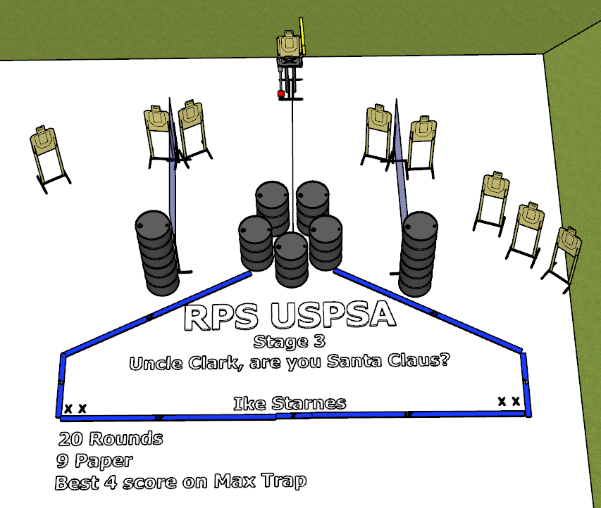

Written Stage Briefing:

Stage 3 – Uncle Clark, are you Santa Claus? - is a 20 round, 100 point, Comstock Course. There are 9 cardboard targets. The best 2 hits per static cardboard target will be scored. The best 4 hits on the Max Trap will be scored.
Start position Both feet touching the Shooting Sports Innovations Xs. Holding Santas bag.
Handgun: Loaded and holstered, wrists below belt.
PCC: Loaded, stock touching belt.

On the audible start signal, engage targets from within the shooting area.

The Max Trap is activated by placing Santa’s bag on the stomp pad.

USPSA / NROI Range Commands:
- Make Ready
- Are you ready?
- Standby
- If finished, unload and show clear.
- If clear, hammer down and holster
- Range is clear

Setup Notes:
4 Single Wall Stands
2 Full Walls
8 Target stands / 16 target sticks
1 Max Trap + cables
1 Bigfoot
1 Santa’s Bag
10+ barrels

